**ERC20 token with block addresss**

In the following project,ERC20 has some special features like you can block some address which you don’t want to transfer token on that blocked addresses and one more feature is also added like remove those blocked address you want to transfer token on that address.

**ERC20_ST Deployed contract address**: 0x267b1a1F9f6a15837D396Cf5d4943Ed61b7060a8

**Test net** : Rinkeby

**Wallet** : Mata mask

**Click on Deploy button and confirm transaction**

After click on confirm button, Transaction Hash is created

**0xf134fb44c10edb68f3631e1b3c416040c3e8c6d881a2e01c5edc88432aa3d9f7**

**1)Transfer Method**

**Parameter**

**Address _to** = 0x5CbF3c13C734934bb30fb09bCC80Fabc14481f32

**int value=** 10000

After filling the parameter, click on transact button of Transfer for transferring the token from one account to other account.

After click on confirm button, Transaction Hash is created

0x05cb8e842783f69319dca6e3581f243d264ad39ce0c04c6ba09cec15028fc7bf

**2)AddBlockAddress Method**

Add the address **(0x5CbF3c13C734934bb30fb09bCC80Fabc14481f32)** you want to block this and click on transact button of addblockaddressToArray.

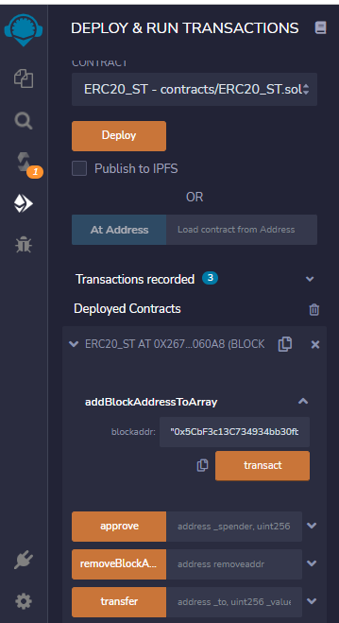

And click on confirm button.

After click on confirm button, Transaction Hash is created

0x25260ec1e61c9c93294be299f023ea9751e0233c2c1adb12375448e0b939ed0b

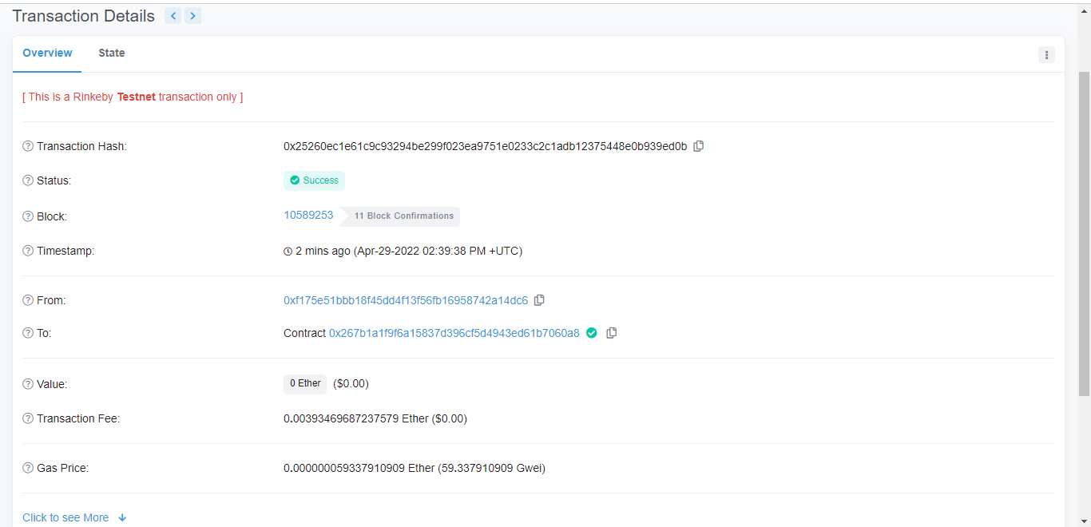

**3)getBlockAddress**

For see the all block address , you can click on getBlockAddress button

**4)Again Transfer of Blocklist address**

again we transfer the blocklistaddress(**0x1739C6926A4e621739D5EB694e2AE979a9F18595**) from Transfer method but it show error like **address is in blacklist.**

Click on transact of Transfer button and put block list address in parameter of transfer method , try to transfer token but it show error like **address is in blacklist address.**

**5)Removing address from blacklist**

Other method is remove block list address is used to remove blocked address **(0x1739C6926A4e621739D5EB694e2AE979a9F18595)** and click on transact of removeblockaddressfrom address .

After transact , click on confirm button of transaction.

**After click on confirm Transaction hash is created:-**

0x0c7654e9808951653790f2d2d431a754def4eee23d32fbf77c0ff4b59e59439c

**6)After Removing below address from block list addresses**

**Address _to=** 0x1739C6926A4e621739D5EB694e2AE979a9F18595

**Value**= 10000

After filling above records in transfer method and try to transfer , token will be transferred because _to address has been removed from blocked list.

**After click on confirm button transaction hash created**

0xa80d7800caa3907e66ecdadee5cb5db9972d58c17b1df368b58dbb89e01a84cd

Thanks